# Lab Solution

Create a document `SOLUTION.md` with:

**1. Cost Estimates:**
- Link to Scenario 1 (baseline) estimate
https://calculator.aws/#/estimate?id=4a7348b938778c703a2a7daaa49fb51eb865b58f
- Link to Scenario 2 (optimized) estimate
https://calculator.aws/#/estimate?id=5e296a174677973b12c3da07ec1c34ad8dad5f58
- Comparison table showing cost differences
https://docs.google.com/spreadsheets/d/1iawI2FATjsO0Q7lG8q2MOFYZXHO-_vYG7suc8ezyOpQ/edit?gid=1313378920#gid=1313378920

**2. Screenshots:**
- Pricing Calculator estimate (both scenarios)
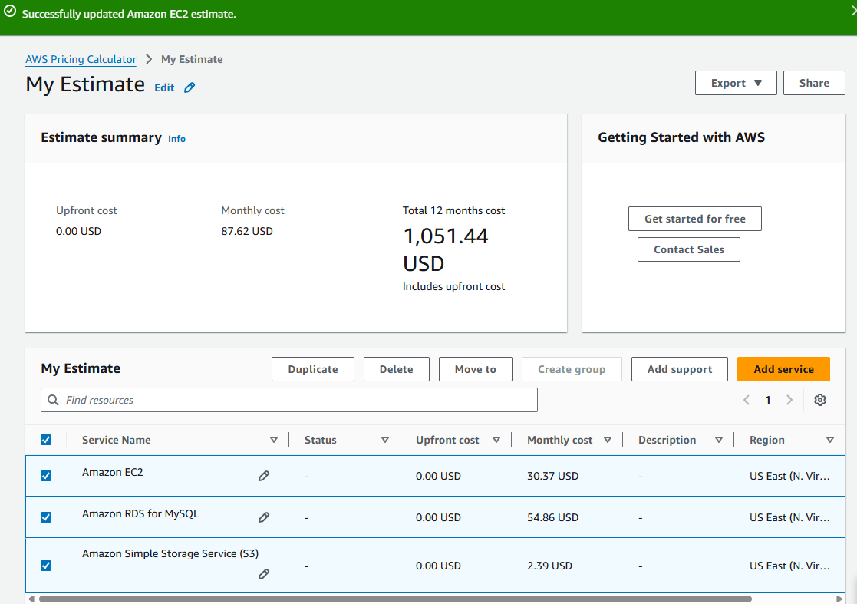
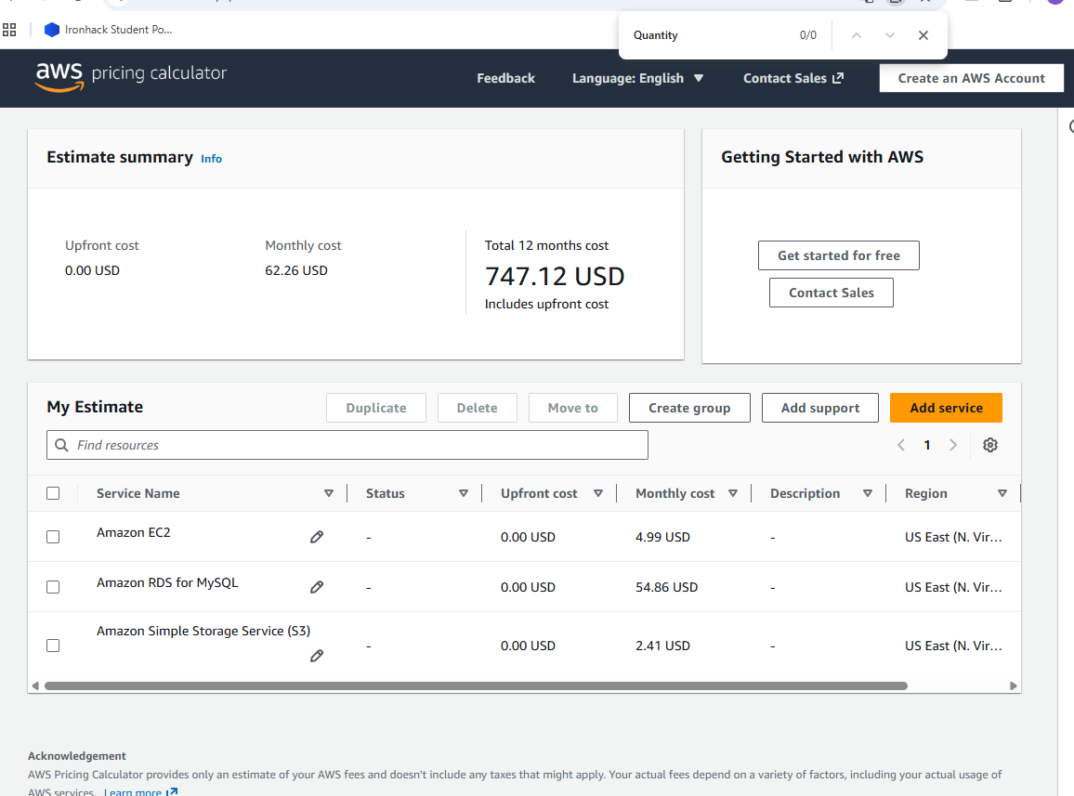
- Billing alarm configuration
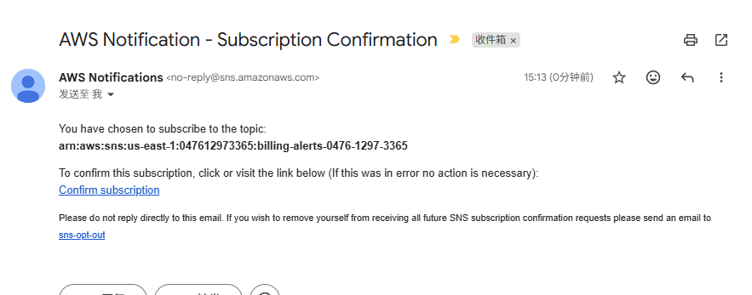
- Cost Explorer views
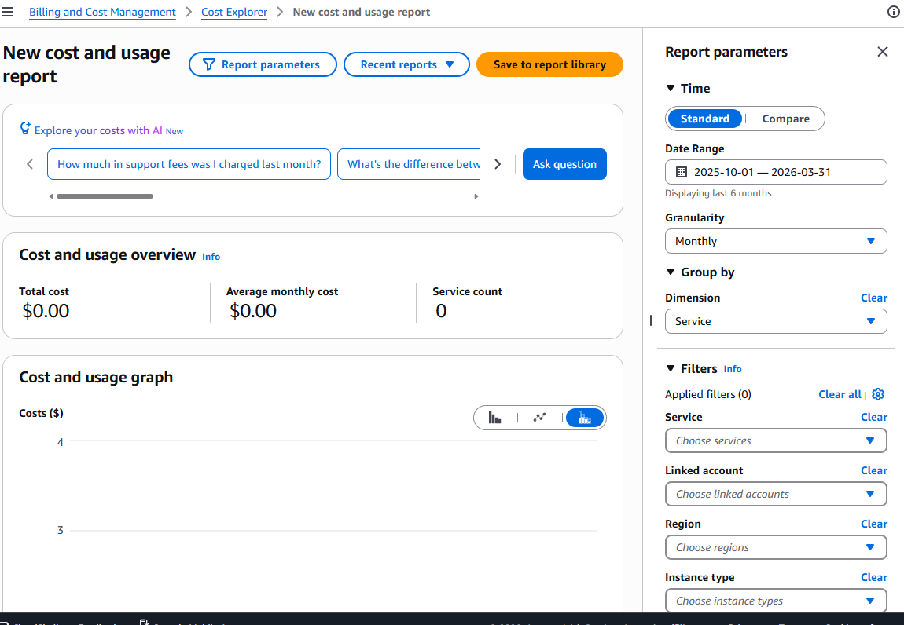

**3. Analysis:**
Answer these questions:

- **What service is the most expensive in Scenario 1?**
Answer: The most expensive service is Amazon RDS for MySQL at $54.86 per month, accounting for approximately 62.6% of the total cost.

- **How much money did you save in Scenario 2? What percentage savings?**
Answer: * Total Savings: $87.62 - $62.26 = $25.36
- Percentage Savings: ($25.36 / $87.62) × 100% ≈ 28.9%

- **What are the trade-offs of running the EC2 instance only during business hours?**
Answer: * Availability: The web application will be completely inaccessible to users during nights and weekends.
- Maintenance: Automated tasks, backups, or security patches that usually run during "off-peak" hours cannot be executed while the instance is stopped.
- Global Reach: This strategy only works for internal tools or localized apps where all users reside in the same time zone.

- **If your website has unpredictable traffic, which pricing model would you use and why?**
Answer: I would use the On-Demand pricing model combined with Auto Scaling.
- Why: On-Demand allows you to pay only for the compute capacity you consume by the second. By using Auto Scaling, the system can automatically add instances during traffic spikes and terminate them when traffic drops, ensuring you don't pay for idle resources while maintaining site performance.

- **How would you further optimize costs without impacting performance?**
Answer: 1. Savings Plans or Reserved Instances (RI): If the database must run 24/7, committing to a 1-year or 3-year term can reduce costs by up to 72% compared to On-Demand.
2. Rightsizing: Monitor the CloudWatch metrics; if the t3.medium CPU utilization is consistently low, I would downgrade to a t3.small or t3.micro.
3. Storage Optimization: Regularly delete old EBS snapshots and RDS backups that are no longer needed.
4. S3 Lifecycle Policies: Move older, infrequently accessed data to S3 Glacier Deep Archive to significantly reduce storage costs.
---

